Good Reads for 5th Graders:

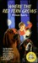Where the Red Fern Grows (Mass Market Paperback)
by Wilson Rawls

Schooled (Hardcover)
by Gordon Korman

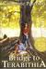Bridge to Terabithia (Paperback)
by Katherine Paterson
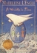A Wrinkle in Time (A Wrinkle in Time Quintet, #1)
by Madeleine L'Engle
Treasure Island (Hardcover)
by Robert Louis Stevenson (shelved 4 times as 6th-grade-reading-list)
avg rating 3.81 — 372,100 ratings — published 1882

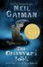The Graveyard Book (Hardcover)
by Neil Gaiman (Goodreads Author) (shelved 4 times as 6th-grade-reading-list)
avg rating 4.11 — 528,346 ratings — published 2008

Want to Read

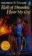Roll of Thunder, Hear My Cry (Logans, #4)
by Mildred D. Taylor
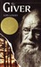The Giver (The Giver, #1)
by Lois Lowry (Goodreads Author
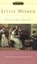Little Women (Little Women, #1)
by Louisa May Alcott
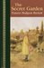The Secret Garden (Hardcover)
by Frances Hodgson Burnett
Sounder (Paperback)
by William H. Armstrong
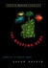The Westing Game (Paperback)
by Ellen Raskin
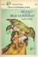Island of the Blue Dolphins (Island of the Blue Dolphins, #1)
by Scott O'Dell
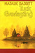Tuck Everlasting (Paperback)
by Natalie Babbitt
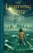The Lightning Thief (Percy Jackson and the Olympians, #1)
by Rick Riordan (Goodreads Author)
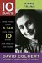Anne Frank (Paperback)
by David Colbert (Goodreads Author)
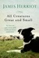All Creatures Great and Small (Paperback)
by James Herriot
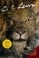The Lion, the Witch, and the Wardrobe (Chronicles of Narnia, #1)
by C.S. Lewis
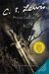Prince Caspian (Chronicles of Narnia, #2)
by C.S. Lewis
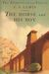The Horse and His Boy (Chronicles of Narnia, #5)
by C.S. Lewis
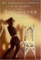The Silver Chair (Chronicles of Narnia, #4)
by C.S. Lewis
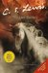The Last Battle (Chronicles of Narnia, #7)
by C.S. Lewis
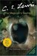The Magician's Nephew (Chronicles of Narnia, #6)
by C.S. Lewis
Cinder (The Lunar Chronicles, #1)
by Marissa Meyer
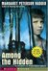Among the Hidden (Shadow Children, #1)
by Margaret Peterson Haddix
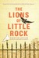The Lions of Little Rock (Hardcover)
by Kristin Levine
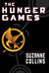The Hunger Games (The Hunger Games, #1)
by Suzanne Collins
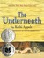The Underneath (Hardcover)
by Kathi Appelt (Goodreads Author)
Waiting for Normal (Hardcover)
by Leslie Connor

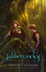Jabberwocky: A Novel (Paperback)
by Daniel Coleman
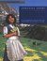Heidi (Hardcover)
by Johanna Spyri
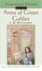Anne of Green Gables (Anne of Green Gables, #1)
by L.M. Montgomery
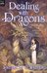Dealing with Dragons (Enchanted Forest Chronicles, #1)
by Patricia C. Wrede
The Collected Stories of Lewis Carroll: Alice in Wonderland/Through the Looking Glass/Phantasmagoria (Paperback)
by Lewis Carroll
The Indian in the Cupboard (The Indian in the Cupboard, #1)
by Lynne Reid Banks
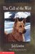The Call of the Wild (Paperback)
by Jack London
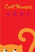Scat (Hardcover)
by Carl Hiaasen
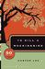To Kill a Mockingbird (Paperback)
by Harper Lee

